LAB #4: Analyzing Zombie Attacks in Washington, DC Using QGIS

Scenario:
Zombies are attacking people in Washington, DC. We have point data representing zombie attack locations and census tract data containing demographic characteristics for each neighborhood. Our goal is to understand why zombies are targeting certain neighborhoods by analyzing the demographic characteristics using QGIS.

Step-by-Step Process:
Step 1: Import Census Tract Data and Ensure Consistent Datum
- Import Census Tract Data (CensusTracts File):
  - Open your GIS software.
  - Import the census tract shapefile containing the demographic data for DC neighborhoods.
  - Check the datum (coordinate system): Ensure the data is in the same datum as the zombie attack data. In this case, we know the zombie data uses WGS 84 (EPSG: 4326). If the census data uses a different system, convert it to WGS 84.

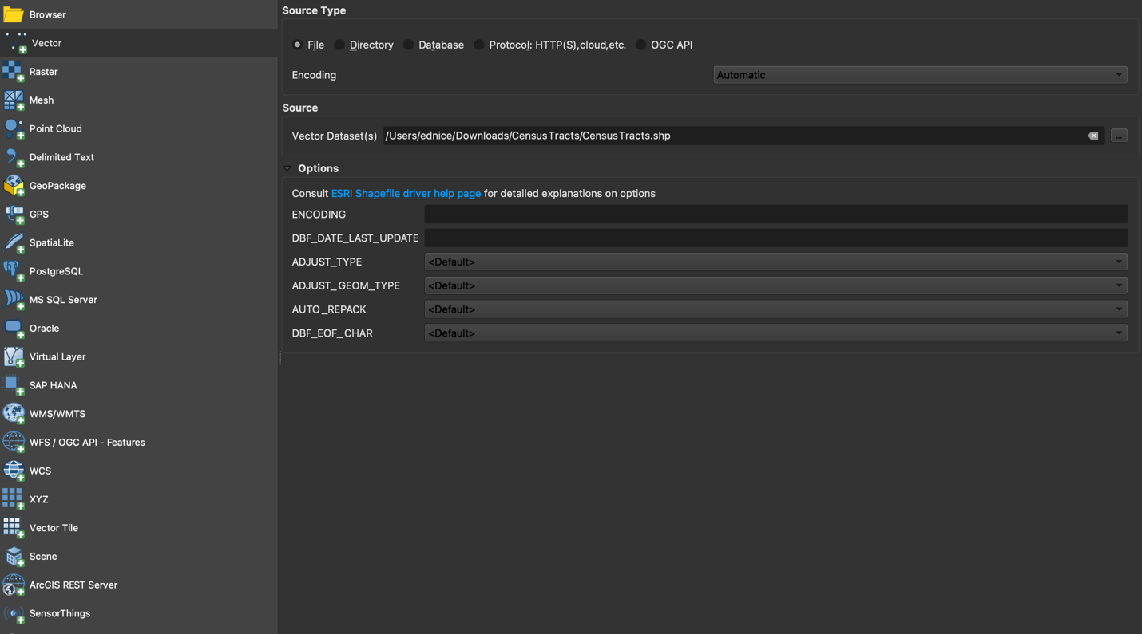

- Import Zombie Attack Data (WGS 84):
Import the zombie attack point data. We already know this is in WGS 84.
  - File Format: First, ensure the zombie attack data is in an appropriate format like CSV, Shapefile (.shp), or GeoJSON. This data contains point locations representing the coordinates of zombie attacks in Washington, DC.
  - Use Layer -> Add Layer -> Add Delimited Text Layer. Set the longitude and latitude fields to plot the zombie attack points on the map. (If the data is a Shapefile, use Layer -> Add Layer -> Add Vector Layer and browse for the Shapefile containing the zombie attack locations. If it's in GeoJSON, use the same Add Vector Layer option and choose the GeoJSON file.)

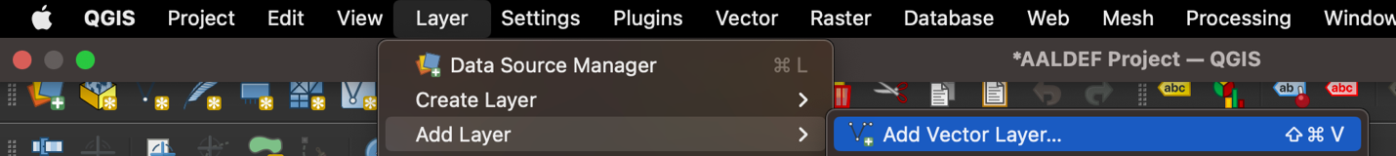

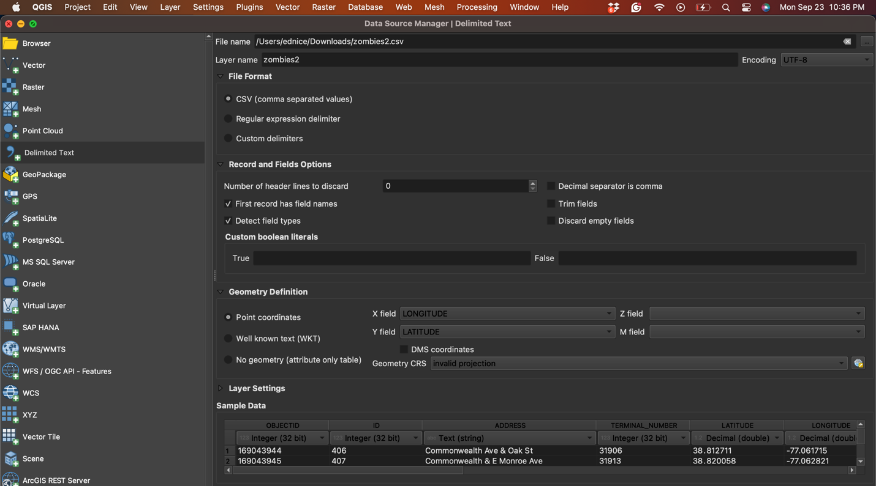

Check the Coordinate System (CRS):
  - The zombie attack data must be in WGS 84 (EPSG: 4326), which is commonly used for geographic coordinates (latitude and longitude).
  - If the data doesn't display correctly, check if the CRS (Coordinate Reference System) is properly assigned:
  - Right-click the zombie attack layer -> Layer Properties -> Information. Look for the CRS. If it’s not WGS 84, you’ll need to reassign it.
  - To reassign the CRS to WGS 84, right-click the layer -> Set CRS -> Set Layer CRS and choose WGS 84 (EPSG: 4326).

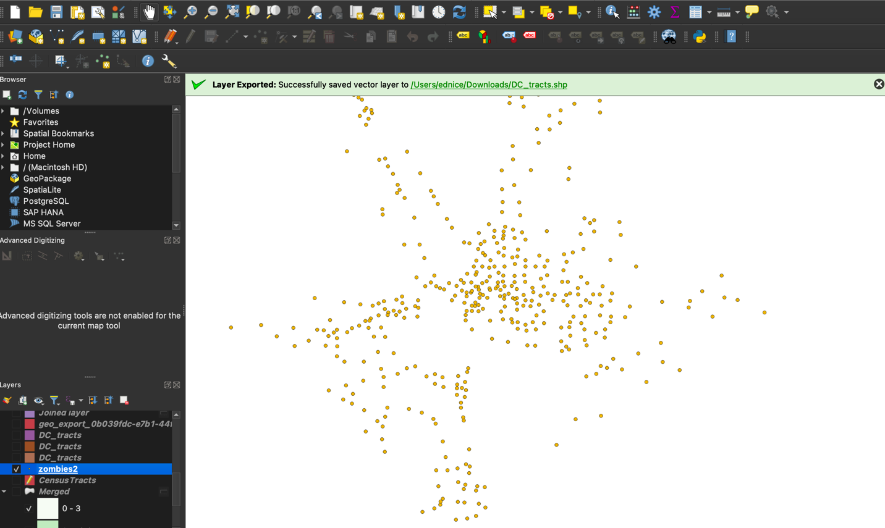

Visualize the Data:
  - Once imported, you should see point markers on the map representing the locations of the zombie attacks in Washington, DC.
  - Make sure the points appear in the correct area. If you don't see them in the expected region, recheck your longitude/latitude fields or the CRS settings.
  - QGIS: Open the attribute table (right-click the zombie attack layer and select Open Attribute Table) to inspect the fields in your data.

Step 2: Selecting Washington, DC Census Tracts by FIPS Code:
- To select only census tracts in Washington, DC, use FIPS Code 11.
- In QGIS, you can do this by:
  - Opening the attribute table for your census tract shapefile.
  - Clicking on the "Select by Expression" button.
  - Using the following expression to filter the data for DC:
"STATE_FIPS" = '11'
  - Run it and scroll down to see the “11” in the State_FIPS variable highlighted.
  - Save this as a new file and label with “DC_Tracts.”
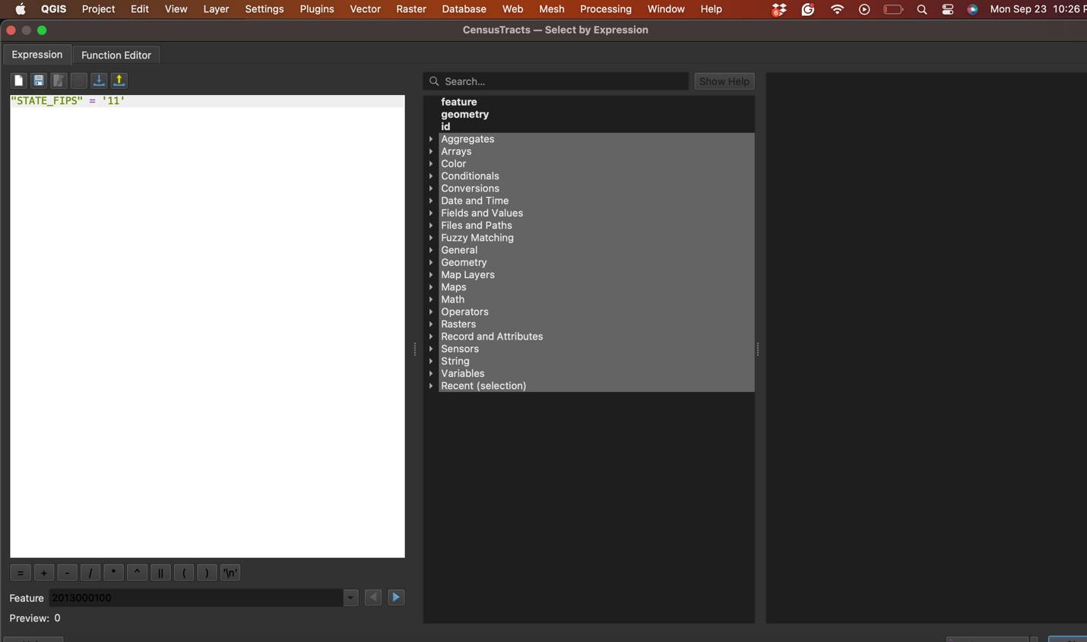

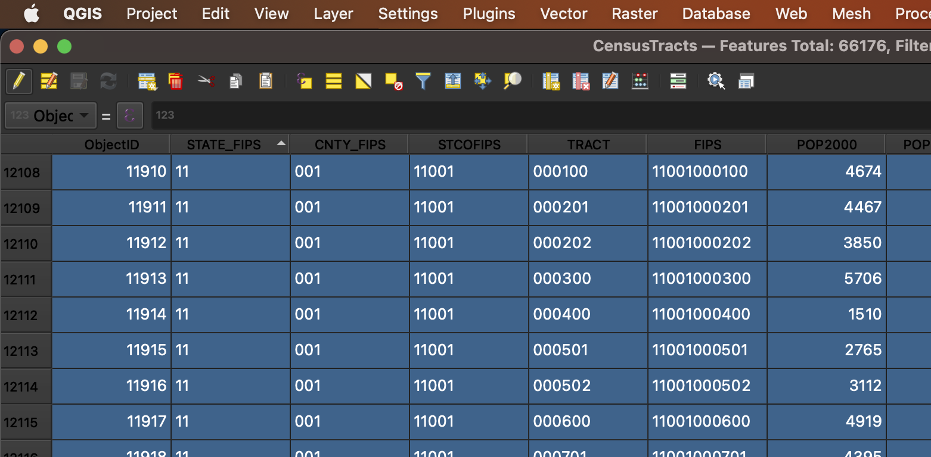

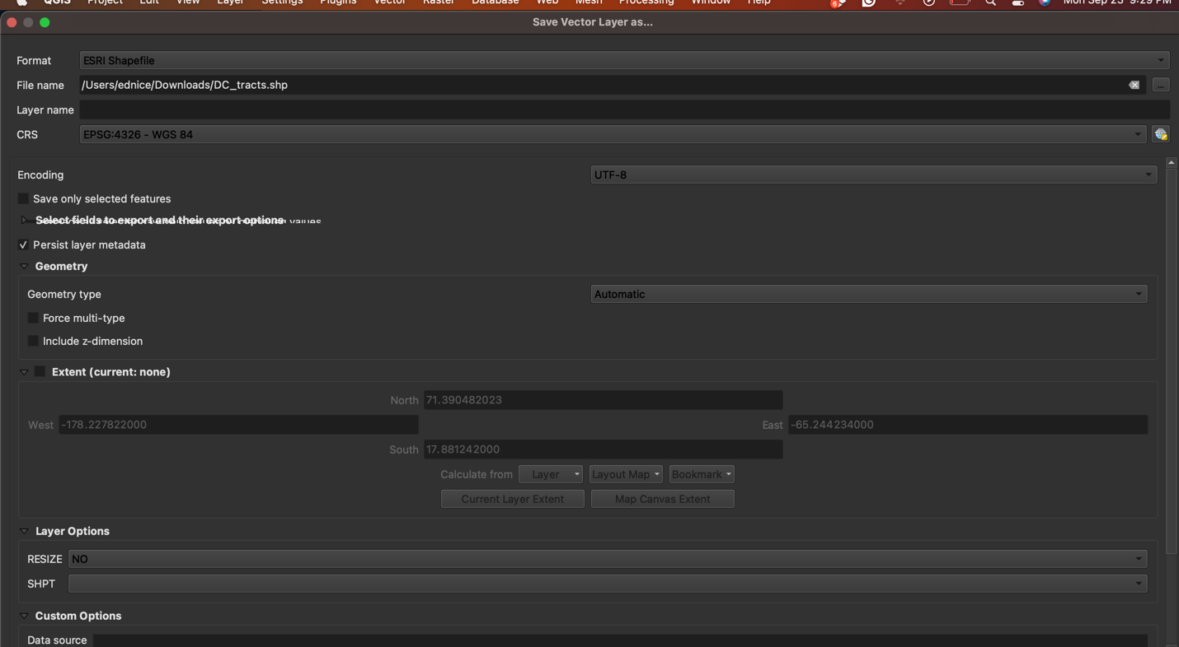

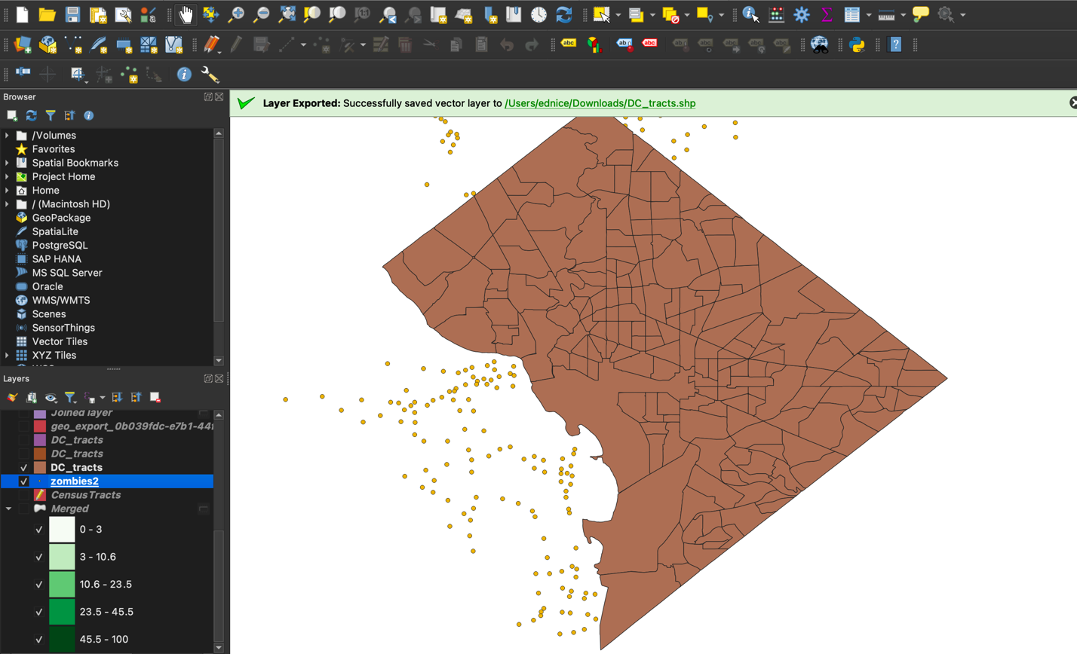

Step 3: Spatial Query – Identifying Targeted Neighborhoods
- Perform a Select by Location Search:
  - We will perform a spatial query to find which census tracts are affected by zombie attacks.
  - QGIS: Go to Vector -> Research Tools -> Select by Location.
  - Select the census tracts as the target layer and the zombie attack points as the source layer.
  - Use the query condition contains or intersects to select census tracts that have zombie attacks.
  - Keep “One to Many” as the feature and this should be the one highlighted as well when you start.
- Subset Data into a New Layer:
  - After running the spatial query, save the result as a new layer that highlights the affected neighborhoods.
  - Select the folder at the bottom of the window to save the result and add the new layer to the map.

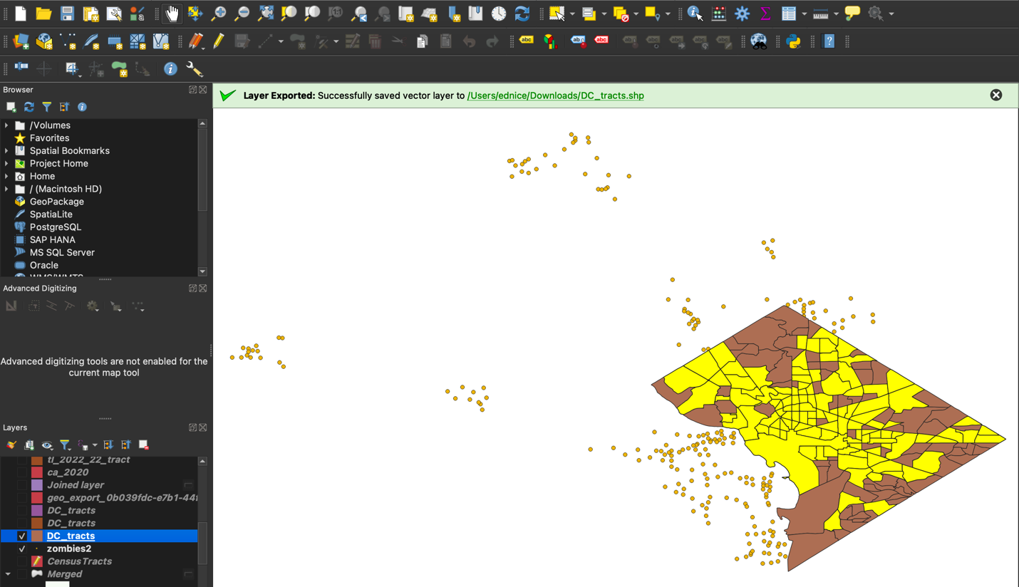

Step 4: Create Buffers Around Zombie Attack Points Using MMQGIS

A. Install the MMQGIS Plugin
- Open the Plugin Manager:
  - In QGIS, click on Plugins → Manage and Install Plugins...
- Search for MMQGIS:
  - In the search bar, type "MMQGIS".
  - When the MMQGIS plugin appears in the list, click on it.
- Install the Plugin:
  - Click the Install Plugin button.
  - Once installed, you should see an MMQGIS menu added to the QGIS menu bar.

B. Create Buffers with MMQGIS
- Access the Buffer Tool:
  - Go to the MMQGIS menu on the top menu bar.
  - Navigate to Create > Create Buffers.
- Configure the Buffer Parameters:
  - Input Layer: Choose your zombie attack point layer.
  - Buffer Distance: Enter the desired buffer distance (e.g., 500 meters or 0.5 km).
Tip: Ensure your distance units match the CRS of your data; if your data is in WGS 84, you might consider reprojecting to a projected CRS before buffering for accurate distance measurements.
  - Dissolve Option: Check the dissolve option if you want overlapping buffers to merge into one continuous area (optional).
  - Output File: Specify a name and location to save the new buffer layer (e.g., “Zombie_Buffers.shp”) or choose to create a temporary layer.
- Run the Tool:
  - Click OK or Run (depending on the dialog) to generate the buffers.
  - The new buffer layer should automatically be added to your QGIS project.
- Verify the Buffer Layer:
  - Zoom to the new layer to ensure that buffers appear around each zombie attack point.
  - Right-click the buffer layer and select Open Attribute Table to review the buffer properties if needed.
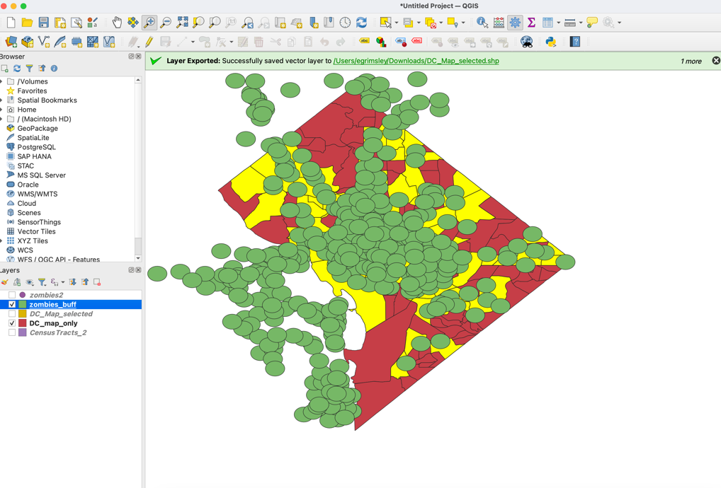

Step 5: Count Zombies Per Census Tract
If you want to count how many zombies fall within each census tract, you can use a similar process:
- Go to Vector -> Analysis Tools-> Count by Polygons
  - Target Layer: Select your Census Tracts layer.
  - Join Layer: Select your Zombie Points layer.
  - Keep NUMPOINTS
  - Run the tool.
- Create Zombies Rate
  - Go to Field Calculator
    - Make a New Field and a Real Decimal Number
    - Go to Fields and Values and click on the NUMPOINTS and then put a divider and then POP2009. Multiply this by 1000 (NUMPOINTS/POP2009*1000)
    - Hit Apply and you should see the new variable in the attribute table.
This will create a new field in the Census Tracts layer, showing how many zombie attack points fall inside each tract.

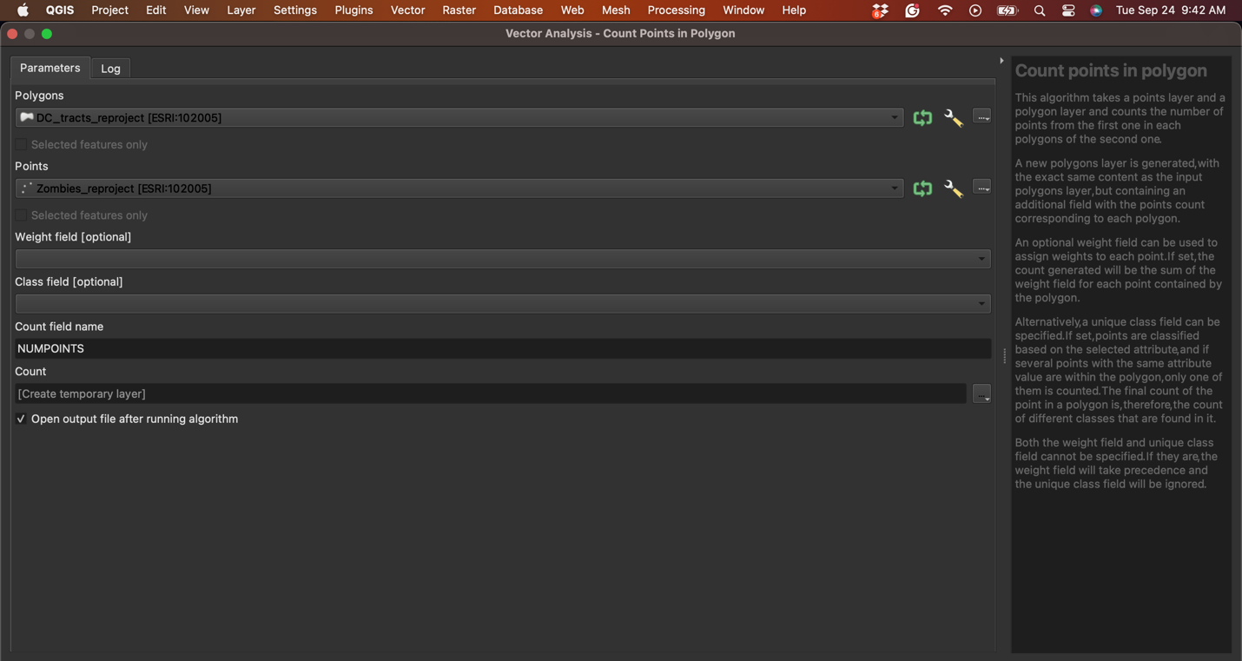

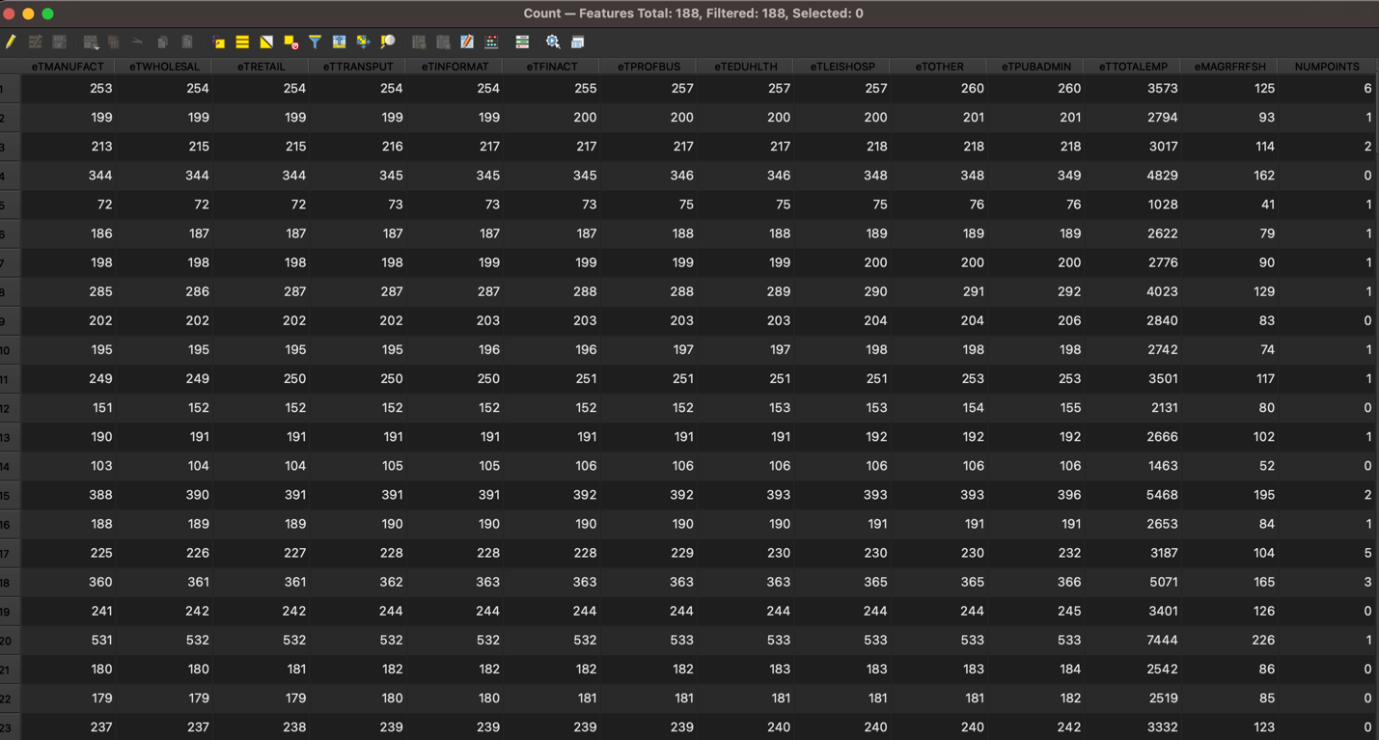

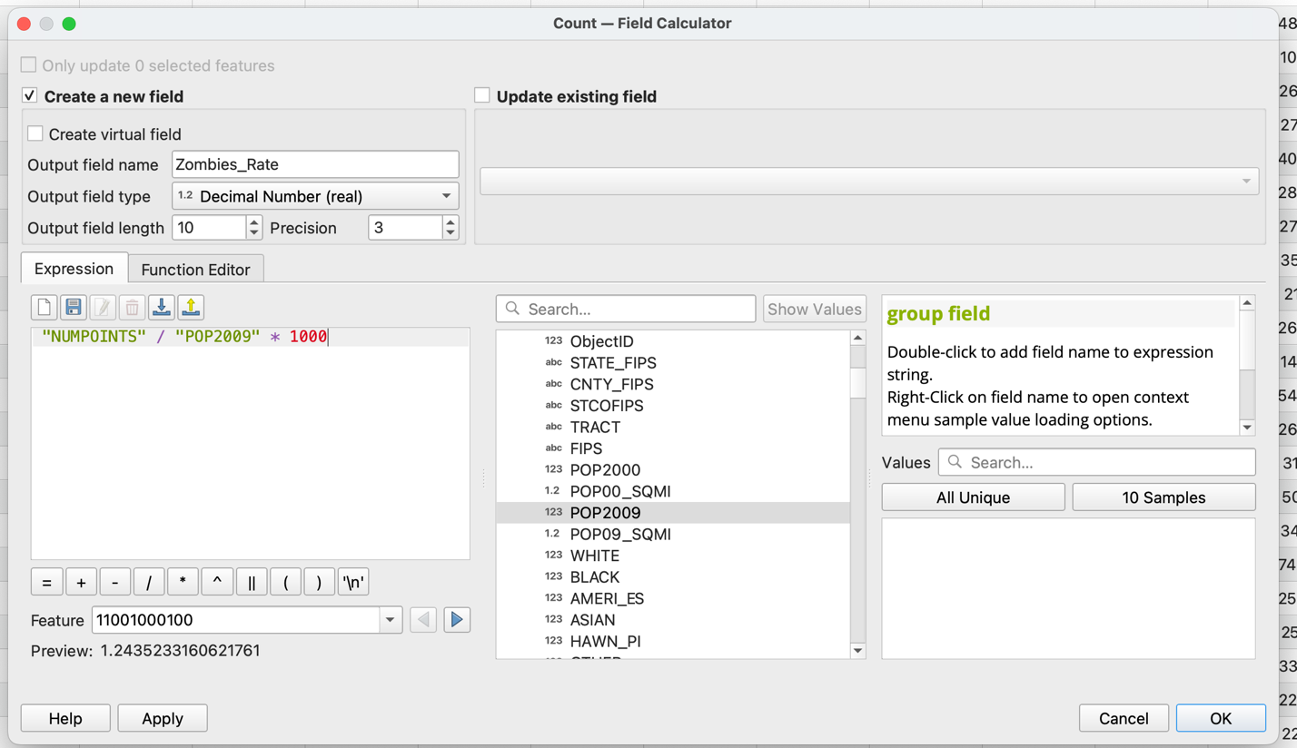

Step 6: Join Attributes by Location
- Join Data for Analysis:
  - Now, we’ll combine the demographic data from the census tracts with the spatial data on zombie attack proximity.
  - QGIS: Go to Vector -> Data Management Tools -> Join Attributes by Location.
  - Set the census tracts as the target layer and the zombie buffer layer as the join layer. Put “intersect” as the function.
  - This step reshapes the data by adding demographic characteristics to areas near zombie attacks.

Step 7: Visualizing the Results
- Open the Attribute Table of your buffer layer by right-clicking the buffer layer and selecting Open Attribute Table.
- Look for the new field that shows the count of zombie points within each buffer.
- If you want to visualize the results:
  - Right-click the buffer layer, choose Properties, and go to the Symbology tab.
  - Choose Graduated symbology based on the new count field.
  - Select a color ramp and classify the values to visualize which DC census tracts contain more zombie points.
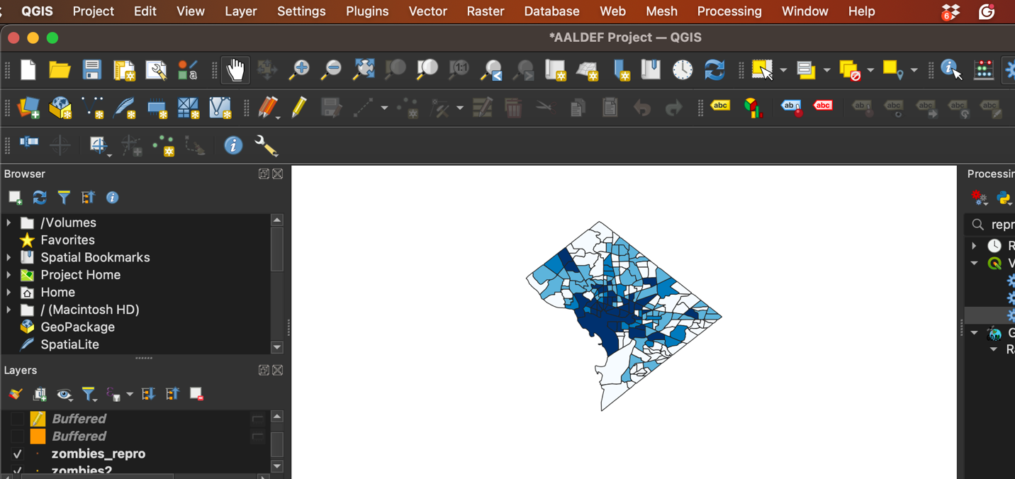

Step 8: Analyze the Results
Now that we’ve spatially combined the data, you can analyze the characteristics of neighborhoods near zombie attacks. This will help identify any trends in demographic factors that might explain why certain areas are targeted.

This process gives us the tools to explore spatial patterns and analyze the relationship between zombie attack locations and neighborhood demographics. You'll be able to repeat this process on your own, and I'll post a video that records these steps for future reference.
Step 9: Lab Upload Instructions: Map of the Zombie Rate
A. Map Requirements
- Title: Provide a clear, descriptive title for your map (e.g., “Zombie Attack Rates by Census Tract – Washington, DC”).
- Legend: Include a legend explaining symbols, color codes, and any classifications used.
- Data Source: Clearly cite the source(s) for your census data and zombie attack data.
- Additional Elements: Ensure all labels, scales, and north arrows are present and clear.
B. Submission Instructions
- Save your final map in the required file format as specified by the instructor.
- Upload your map file to the designated online platform along with any accompanying documentation (e.g., brief methodology summary).
C. Final Check
- Review your map to confirm that all required elements (title, legend, data source, etc.) are included and clearly presented before submission.

